Put the title of your contribution here
Rainer Hain¹*, Sven Scharnowski², Christian J. Kähler¹
¹University/Company, Institute/Department/Division, City, Country
²University/Company, Institute/Department/Division, City, Country
*corresponding.author@example.com

Abstract
This abstract should not exceed 2 pages. Please submit the PDF file at “www.unibw.de/ispiv2019/abstracts-paper”. The pdf file should have a unique name, e.g. “ISPIV2019_Abstract_[UniversityName]_[AuthorName]_[December_11_2018].pdf”. Submission deadline is January 15, 2019.
Guideline for the abstract: Here are three examples of citations: Kähler et al. (2016), Raffel et al. (2018), and Discetti et al. (2015). Here is an example for an equation: the function value is calculated as
y = m·x+t (1)

An example for figures is shown in Fig. 1(a) and Fig. 1(b).

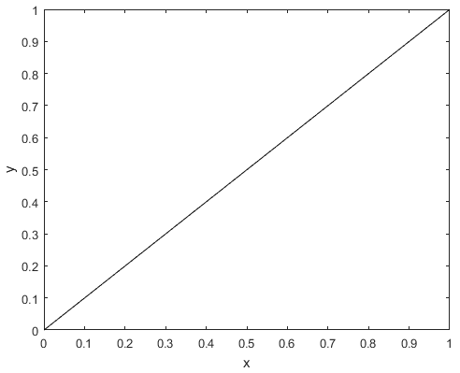
(a) test figure (b) test figure
Figure 1: Two test figures.

References
Discetti S, Agüera N, Cafiero G, and Astarita T (2015) Ensemble 3D PTV for high resolution turbulent statistics. In 11th International Symposium on Particle Image Velocimetry - PIV15, Santa Barbara, California, USA, September 14-16
Kähler CJ, Astarita T, Vlachos PP, Sakakibara J, Hain R, Discetti S, La Foy R, and Cierpka C (2016) Main results of the 4th International PIV Challenge. Experiments in Fluids 57:97
Raffel M, Willert CE, Scarano F, Kähler CJ, Wereley ST, and Kompenhans J (2018) Particle Image Velocimetry. Chapter Tracer Particles, page 39. Springer. 3rd edition

