AAMS22 information package

  - How get to the Campus:
- By public transport:
- Please don't forget that wearing a mask is mandatory on planes, trains, and busses in Germany.
- From the airport, take the S8 train ("S-Bahn"), direction Herrsching, to the Ostbahnhof (east station). From there take U5 (see below)
- From the train station, take the U5 subway/metro ("U-Bahn"), direction Neuperlach Süd, to its terminus. There, change to Bus 199 (dir. Campeon West) or 217 (dir. Unterhaching). See below for the correct bus stop.
- Alternatively, you can walk from Neuperlach Süd (ca. 15 min, see campus map).
- By car/taxi: See below for the correct gate.

  - How to enter the Campus:
- Most importantly, you will need valid photo ID (i.e. a passport or national ID card) to enter the campus. There will be no exceptions to this rule.
- In the mornings, there will be a team of people at the gate dedicated to conference attendees, i.e. there is no need to go through the normal route to enter the Campus.

  - How to get to the welcome reception venue on Sunday night:
- Bus stop: "Universitätsstraße (Neubiberg)".
- There is visitor parking available at the main gate.
- Please enter the campus via the main gate (Westtor), as marked on the campus map.
- From there, walk straight ahead for ca. 350 m, then follow the signs.
- If you get lost on campus, just ask anyone to show you the way to "UniCasino"

  - How to get to the conference venue Monday-Wednesday morning:
- Between 8:15 and 10:30, we will open the north gate for conference attendees. If you arrive later, you will need to enter via the west gate (see above). Someone will come and pick you up there.
- Bus stop: "Lilienthalstraße".
- There is a parking off Zwergerstraße, just a few steps away.
- Please enter the campus via the north gate (Nordtor), as marked on the campus map.
- There will be signs on campus to guide you to the conference venue.
- If you get lost on campus, just ask anyone to show you the way to "Audimax"

  - How to exit the campus:
- There are a number of revolving-door exits on campus, including where you entered the campus. You can use any of these. Please press the button labelled "Exit" and please make sure not to duck under the barriers - that's a very unpopular behaviour around here.

  - How to get to the conference dinner on Tuesday night:
- There will be a bus transfer, leaving at the conference venue, at 18:30 on Tuesday.
- Travel back to your hotel is on an individual basis.

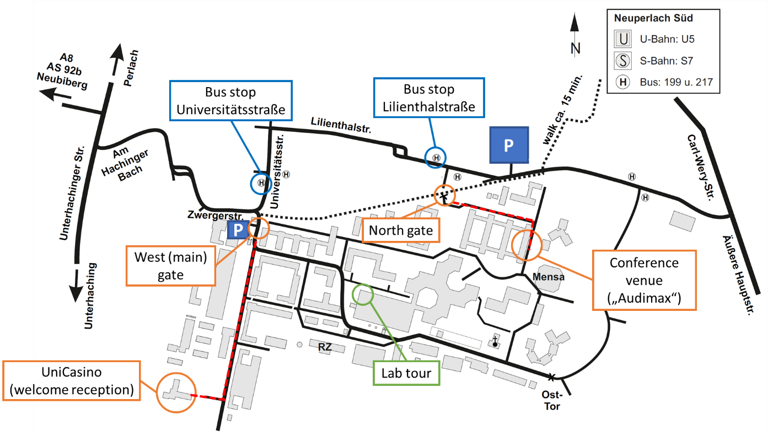

  - Information regarding posters:
- Please print your poster in portrait orientation.
- Do not exceed DIN A0 in size (84 x 119 cm).
- Mounting material (pins and tape) will be available.
- Please check the poster walls for your submission ID and only attach your poster in the dedicated place.
- Please remove your posters during coffee break on Wednesday at the latest.

  - Information regarding oral presentations:
- Invited presentations will last for 30 minutes plus 5 minutes of discussion.
- Standard presentations will last for 15 Minutes plus 5 minutes of discussion .
- Please upload your presentations in advance at the desk in the foyer.
- There, you will be asked if you agree to have your talk videotaped and uploaded to YouTube after the conference.

  - Information regarding COVID:
- Please only travel to the conference if you don't show any symptoms.
- Currently, there is no need to wear masks in the conference venue, however, please consider doing so on a voluntary basis.
- If any regulations change, you will be informed immediately by email.

  - Conference telephone:
- For any questions during the conference, you can call +40 89 6004 2800 or
+49 89 6004 2534 at any time.

